Python Template

https://docs.djangoproject.com/en/5.0/ref/forms/api/

**Upgrade Pip-**

**python -m pip install --upgrade pip**

it will check the environment of python—

python -m ensurepip --default-pip

---to set virtual environment---

python -m venv env

./env/Scripts/Activate.ps1

python -m pip install Django

django-admin –version

django-admin startproject hello_world_project

cd hello_world_project

python manage.py migrate

python manage.py runserver

when you run

<http://127.0.0.1:8000/admin>

so first create login

python manage.py createsuperuser

WSGI and ASGI are both interfaces for Python web applications, but they serve different purposes. WSGI is a synchronous interface that allows for communication between a web server and a web application. ASGI, or Asynchronous Server Gateway Interface, is an extension of WSGI that supports asynchronous operations

---------------Create Django App------------------------------

python -m venv env

./env/Scripts/Activate.ps1

python -m pip install Django

django-admin –version

django-admin startproject MyApp

cd MyApp

python manage.py startapp DApp

python manage.py migrate

python manage.py runserver

allow static file

STATICFILES_DIRS=[

    BASE_DIR,"static"

    ]

Form validation  
I've gone through that error just now.

Forgot to pip [install django-crispy-forms](https://django-crispy-forms.readthedocs.io/en/latest/install.html#installing-django-crispy-forms)

pip install django-crispy-forms

pip install crispy-bootstrap4

settings.py

INSTALLED_APPS = [

    'formvalidation.apps.myAppNameConfig',

    'django.contrib.admin',

    'django.contrib.auth',

    'django.contrib.contenttypes',

    'django.contrib.sessions',

    'django.contrib.messages',

    'django.contrib.staticfiles',

    'crispy_forms',

    'crispy_bootstrap4'

]

DEFAULT_AUTO_FIELD = 'django.db.models.BigAutoField'

CRISPY_TEMPLATE_PACK = 'bootstrap4'

or

if showing some problem so first update the pip within the environment

python.exe -m pip install --upgrade pip

pip install django-bootstrap-v5

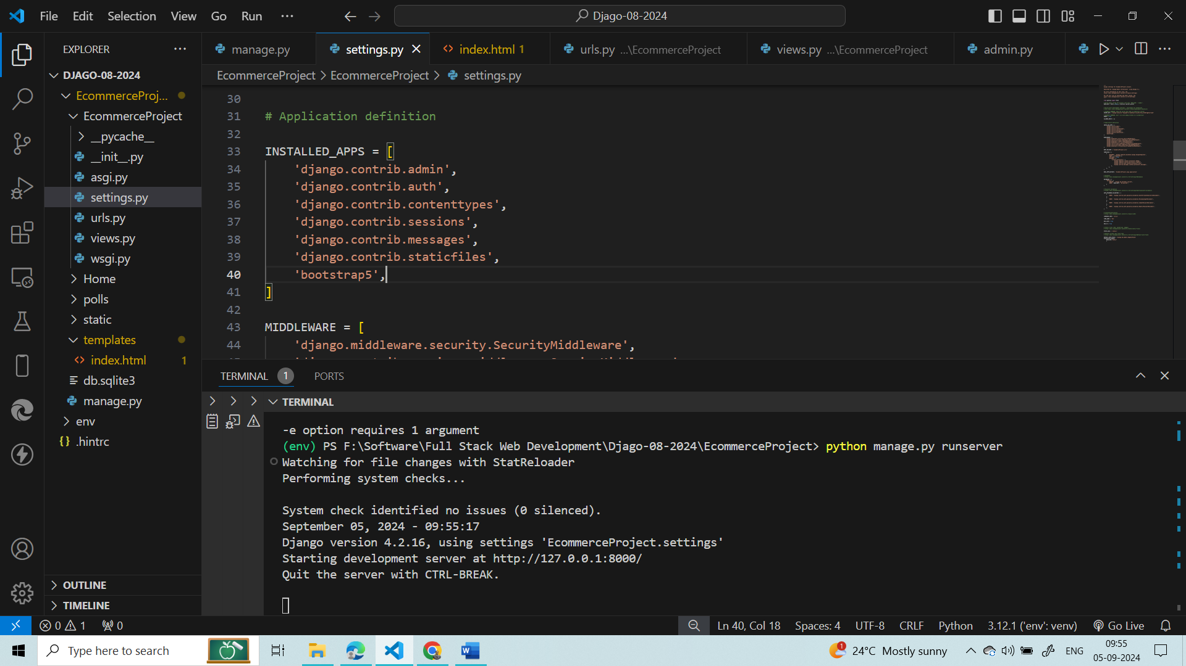

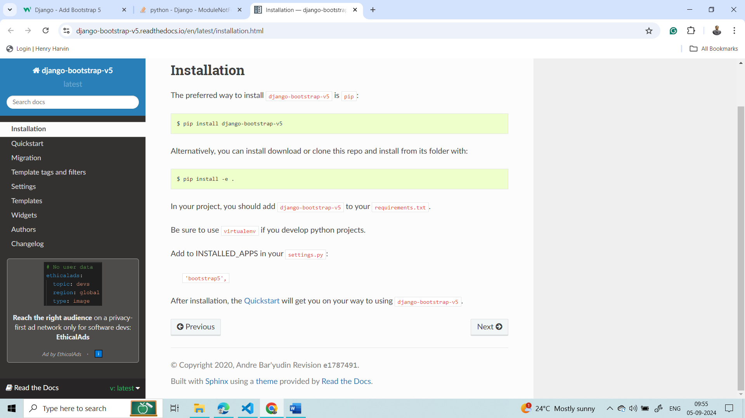

<https://django-bootstrap-v5.readthedocs.io/en/latest/installation.html>

apps.py

from django.apps import AppConfig

class myAppNameConfig(AppConfig):

    name = 'formvalidation'

    verbose_name = 'A Much Better Name'

<https://stackoverflow.com/questions/65238459/templatedoesnotexist-at-users-register-bootstrap5-uni-form-html>

http://127.0.0.1:8000/admin



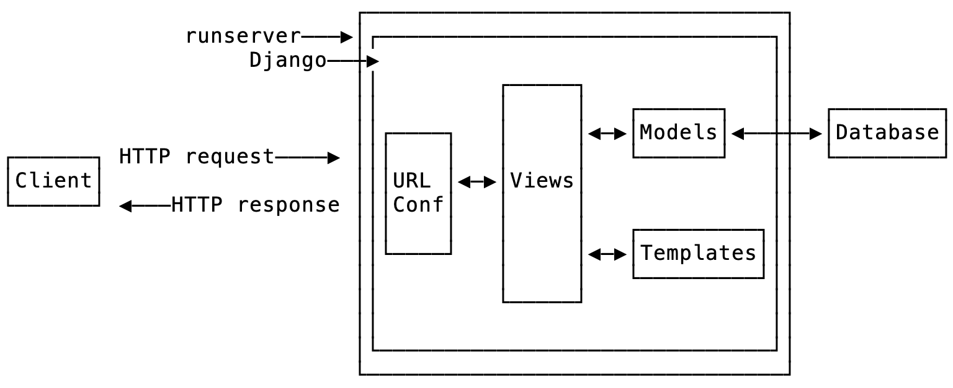

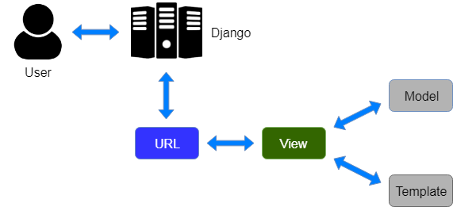

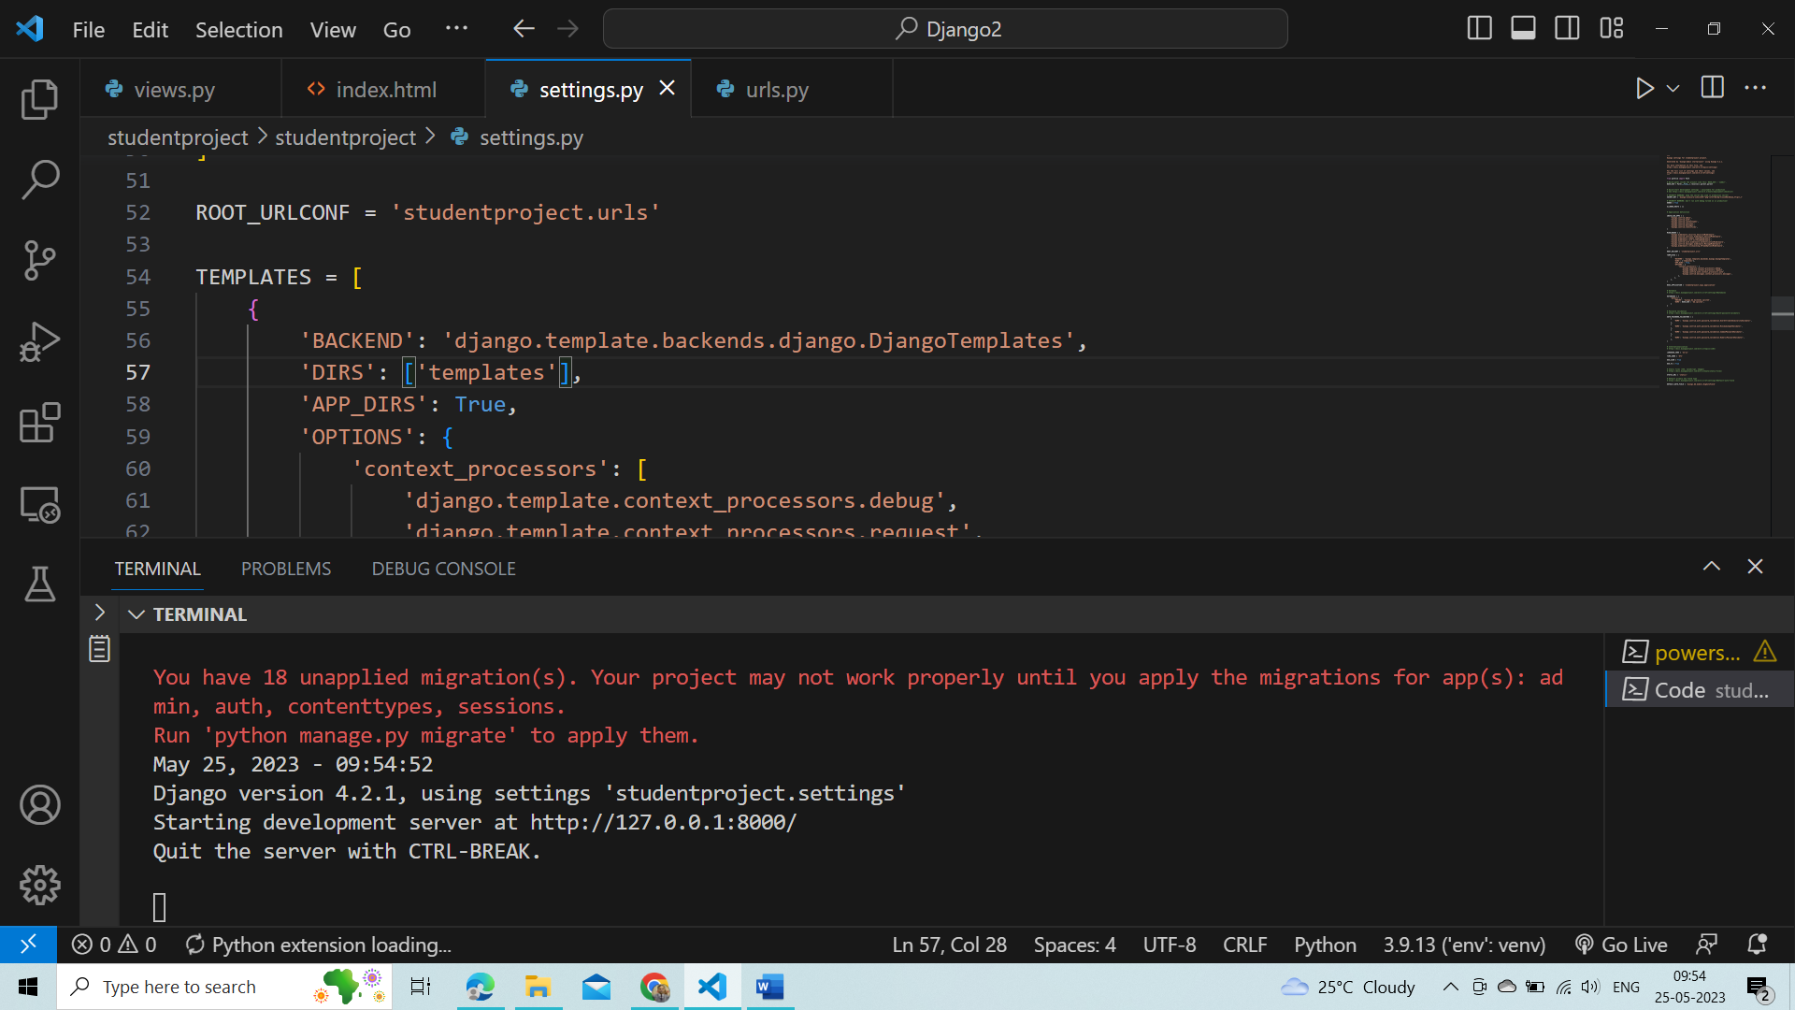

For mysql connectivity

settings

DATABASES = {

    'default': {

        'ENGINE': 'django.db.backends.mysql',

        'NAME': 'india',

        'USER':'root',

        'PASSWORD':'root',

        'HOST':'localhost',

        'PORT':'3306'

    }

}

pip install mysqlclient

python manage.py runserver

python manage.py makemigrations

python manage.py migrate

python manage.py runserver

apps.py

from django.apps import AppConfig

class myAppNameConfig(AppConfig):

    name = 'djangosql'

    verbose_name = 'A Much Better Name'

pip install django-crispy-forms

STATICFILES_DIRS=[

    BASE_DIR,"static"

    ]

use india;

create table employee

(

eid varchar(20),

ename char(100),

eemail varchar(30),

econtact varchar(15)

)

INSTALLED_APPS = [

    'djangosql.apps.myAppNameConfig',

    'django.contrib.admin',

    'django.contrib.auth',

    'django.contrib.contenttypes',

    'django.contrib.sessions',

    'django.contrib.messages',

    'django.contrib.staticfiles',

    'crispy_forms',

]

Id must be included into the database

use india;

show tables;

create table employee

(

eid varchar(20),

ename char(100),

eemail varchar(30),

econtact varchar(15)

);

ALTER TABLE employee ADD id integer AUTO_INCREMENT NOT NULL PRIMARY KEY FIRST;

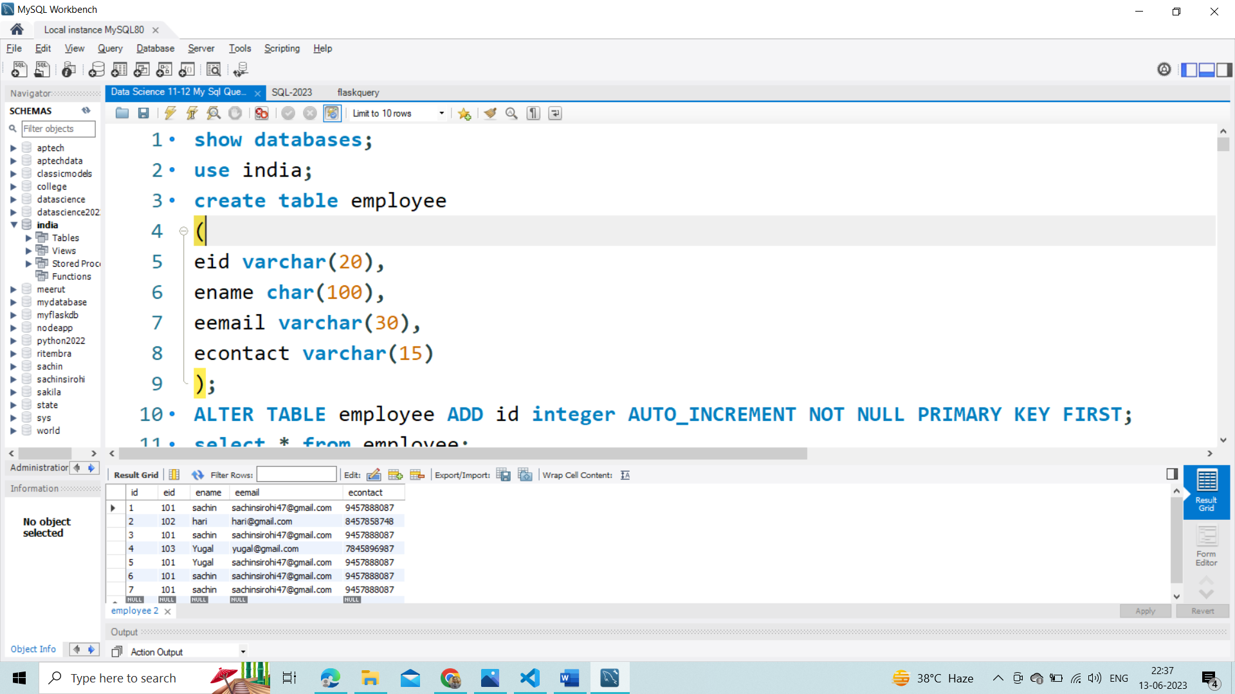

UserFormCreation

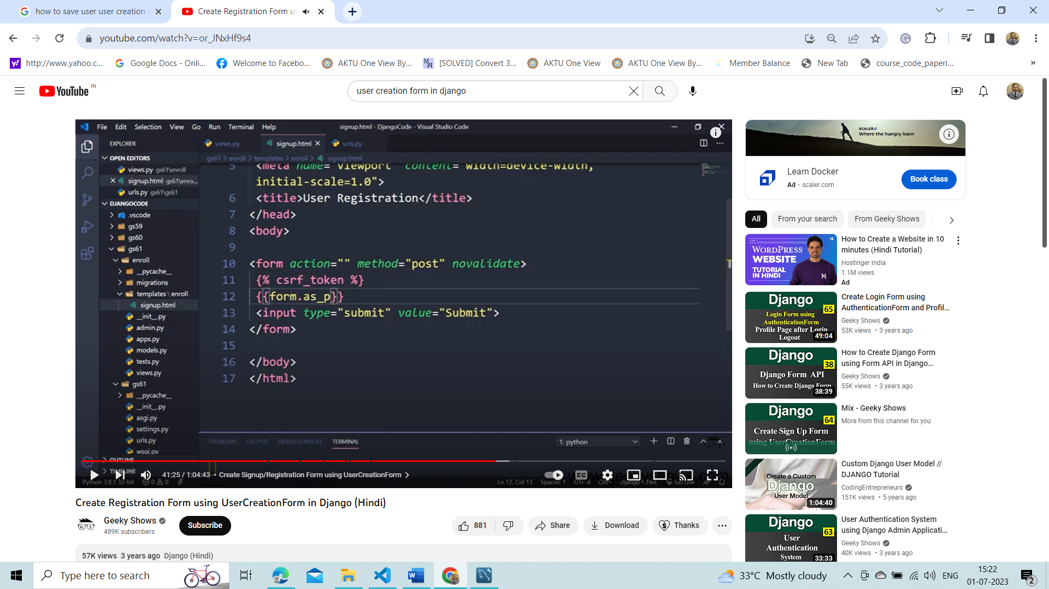

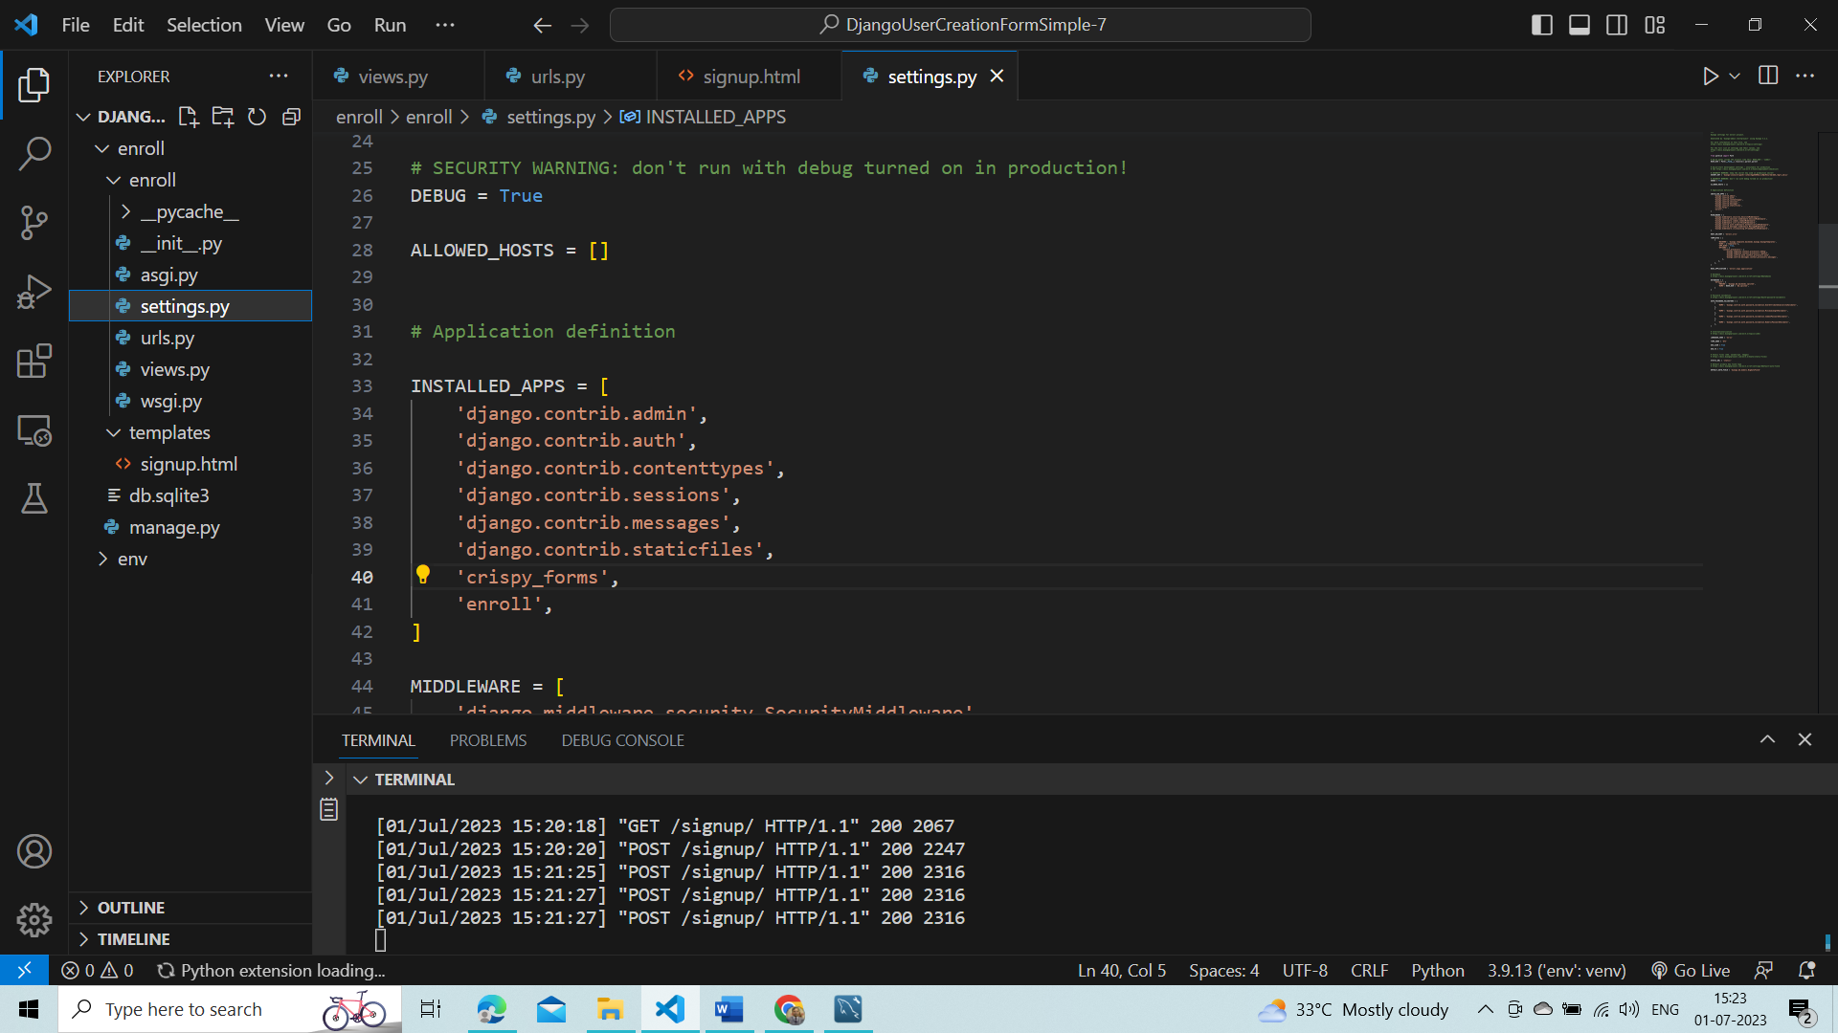

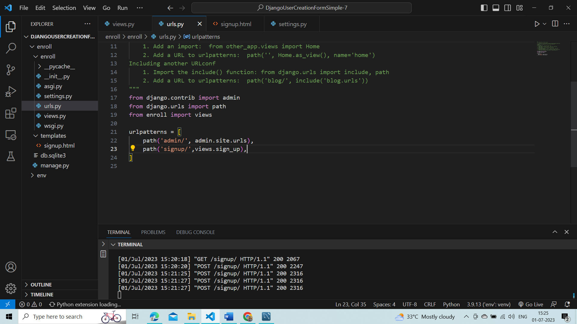

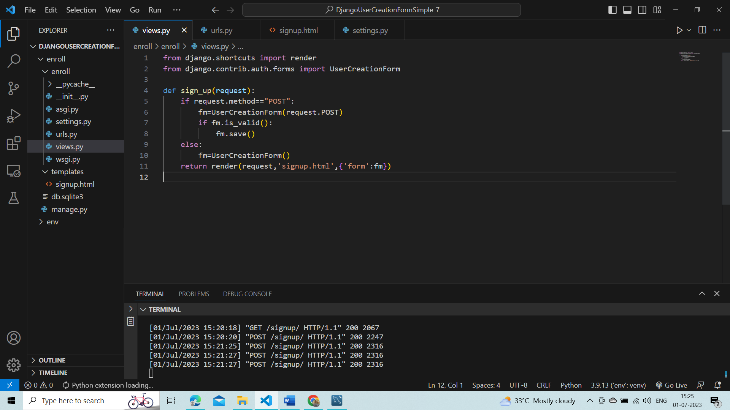

Save Value to SQL Lite by default

